Memorial Day Tribute Monday, May 26, 2025
11:00 am
Gathering
Posting the Colors Boy Scouts, Troop 104 & 250
Welcome Allen Pearson
“National Anthem” Jessica Bounds

Invocation Pastor Cindy Knudsen Church of Nazarene, West Main Street, Manchester
“The Missing Man Table” Yvonne Atkins, Past President Pledge of Allegiance to the U.S. Flag Arthur Pearson Recognition of the Fallen Comrades Arthur Pearson Speaker PFC Carl (Bubber) Fishburn
503 Infantry 173rd Airborne Brigade Stationed Bian Hoa, Vietnam 1965-1966

Lowering the U.S. Flag Boy Scouts, Troop 104 & 250
“Taps” Sadie Hancock, Bugler
Placing the Wreath Melissa Trujillo, Woman’s Club “God Bless America” Jessica Bounds
Benediction Pastor Cindy Knudson
A Special Word of Appreciation

The American Legion Post 88 The VFW Post 4670
Arthur Pearson
Boy Scouts, Troop 104 & 250
Manchester Kiwanis Club Manchester Lions Club Manchester Woman’s Club Meriwether County Rotary Club
Manchester Fire Department
Meriwether County School System Wraparound Center and a host of others for helping make this Memorial Day celebration memorable and inspiring.

Reception
A reception follows immediately after the Memorial Day Tribute
at Manchester Mill

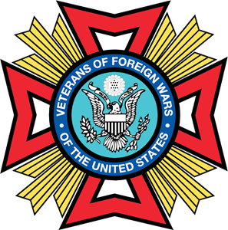
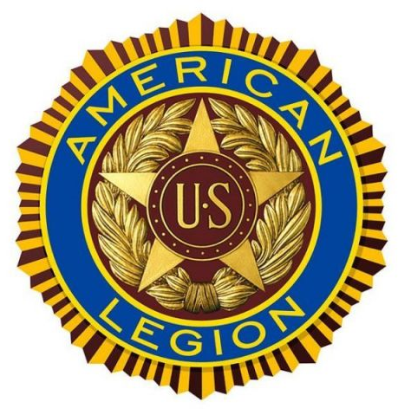

The Missing Man Table

This table is reserved to honor our brave and selfless American military members who have perished on the battlefield, those who have not been returned to us after being taken prisoner on foreign soil, and for those who went missing and have not found their way back home.

The Table is Round
to show our everlasting concern for our fallen and our missing.
The Table, Set for One
is small, symbolizing the frailty of one prisoner alone against his or her suppressors.
The White Tablecloth
symbolizing the purity of their intentions to respond to their country’s call to arms.
The Single Red Rose
reminds us of the life of each of our fallen, and the loved ones and friends who miss them everyday.
The Vase is Tied with a Red Ribbon
a symbol of our continued determination to remember our fallen and find our missing.
The Slices of Lemon
an the plate is to remind us of the bitter fate of those who will never return.
A Pinch of Salt
symbolizes the tears endured by the friends and families of those who have fallen and of those who have not returned.
The Inverted Wise Glass
they cannot toast with us at this time.
The Empty Chair
they are no longer with us.
The Candle
is reminiscent of the light of hope that lives in our hearts to illuminate their way home from their captors to the open arms of a grateful nation.

Memorial Day Tribute Monday
May 26, 2025
Manchester Mill

11:00 am



